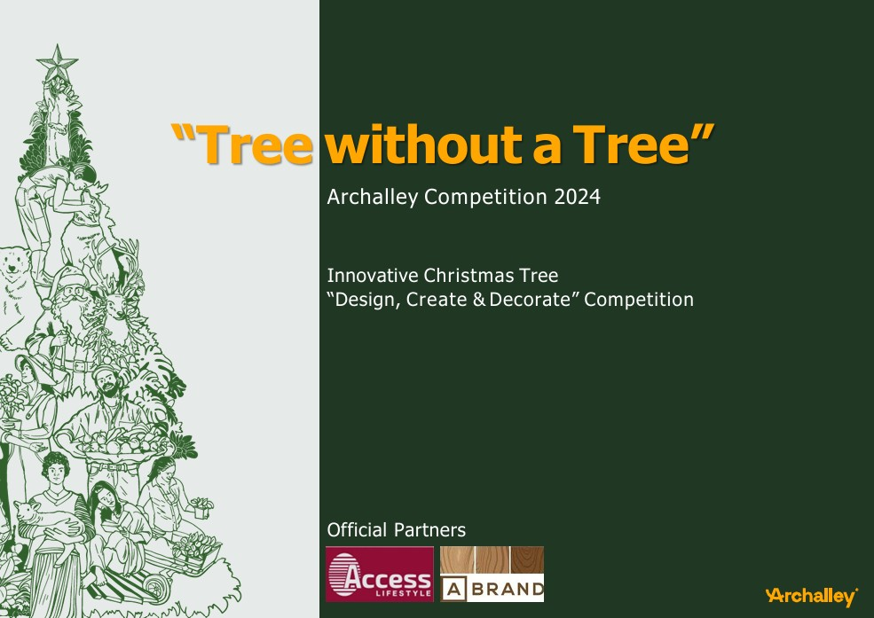



**A.PAMODA GNANATHISSA**

**UNIVERSITY OF MORATUWA**

A **Christmas tree ?**

The use of **evergreen** plants to celebrate the birth of Jesus. Evergreen boughs symbolized **life, renewal, and resilience**, especially during the harsh winter months. These trees were decorated with apples to represent the Garden of Eden. Early decorations included handmade ornaments, popcorn garlands, and lit candles.

There are 2 types of Christmas trees.

**Natural Christmas trees & Artificial Christmas trees**

* **Deforestation:** Approximately **120 million natural Christmas trees** are cut down each year globally. Cutting wild trees from forests harms ecosystems and wildlife if not managed sustainably.
* **Carbon Footprint:** Growing, harvesting, and transporting trees produce emissions. A natural Christmas tree has an average carbon footprint of **16 kg of CO2**, including transportation.
* **Waste:** Improper disposal (e.g., sending trees to landfills) produces **methane**, a potent greenhouse gas, as they decompose.
* **Manufacturing Emissions:** One artificial tree produces around **40 kg of CO2**— nearly triple that of a natural tree.
* **Non-Biodegradability:** long-term landfill waste. They often cannot be recycled due to mixed materials
* **Transportation:** Often manufactured overseas, shipping further adds to their carbon footprint.

Over **3 million tons of waste** are generated during the Christmas season globally, including discarded trees and decorations.

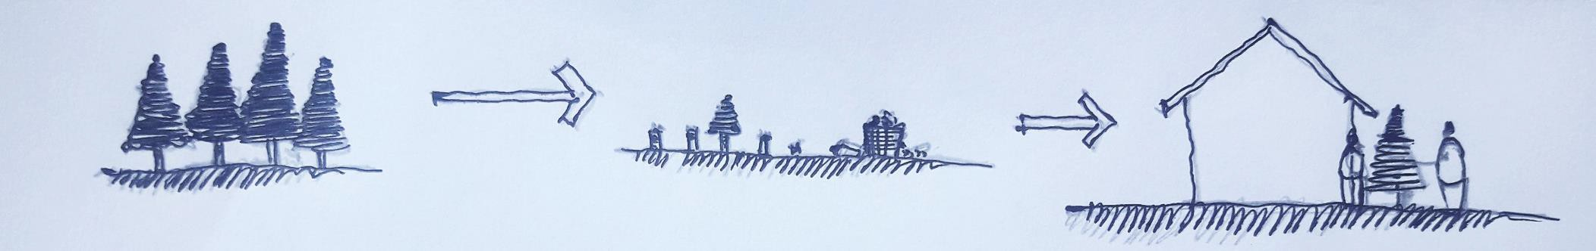What We Normally Do.

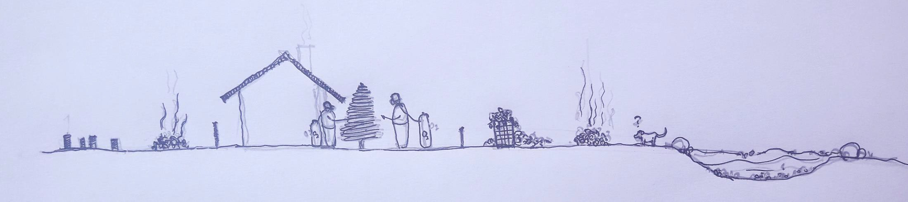Results.

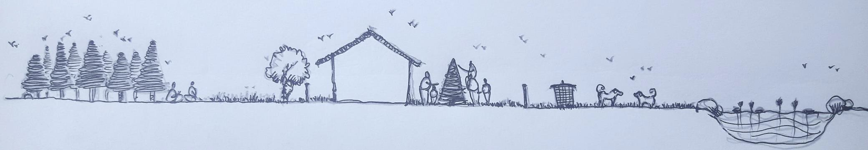Lets create.

The practice of **cultivating and harvesting pine trees** specifically for the Christmas season is often justified as an environmentally neutral activity due to the replanting of trees. However, this approach fails to address the broader ecological implications. While farmed Christmas trees contribute **temporarily to carbon sequestration** during their growth cycle, their harvesting and subsequent disposal significantly diminish these benefits.

A more sustainable and eco-conscious alternative lies in **adaptive reuse and creative recycling**. By refraining from cutting live trees and instead designing Christmas trees from materials readily available in our homes, we can align festive traditions with environmentally responsible practices.

# Design Concept

This project reinterprets the traditional Christmas tree by adopting an eco-conscious approach rooted in architectural principles of **sustainability, modularity, and adaptive reuse**. The concept is to create a charismas tree with things what we have and what we through away to the nature.

My design was Crafted entirely from **discarded vehicle components and plastic bottles** from the garage we have in our house, the design embraces the competition’s ethos of environmental stewardship while showcasing the potential of repurposed materials in creating innovative, spatially dynamic forms.

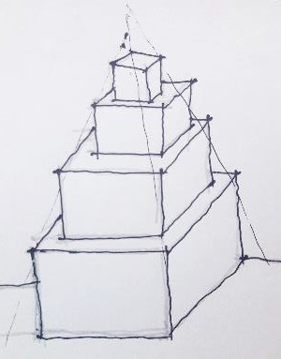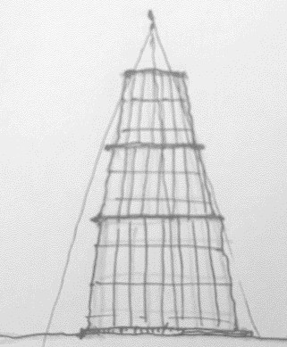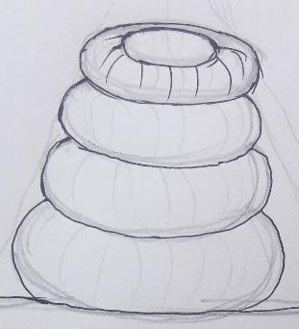And I wanted to create a tree that every other people can make it by themselves with things they have. As I did. Specially the form of the tree. As examples, pots, tiers, tubes, boxes, containers, ect.

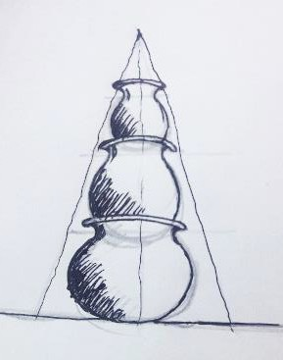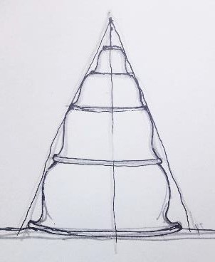

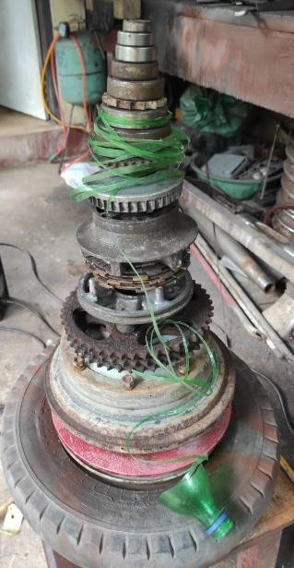**Materiality and Structural framework**

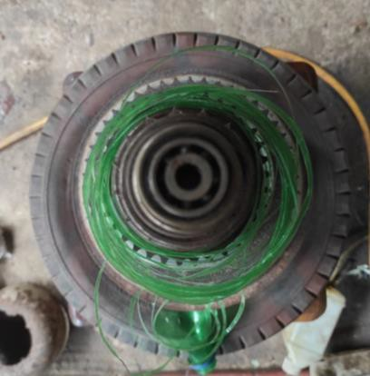The tree’s structural framework is conceived as a vertical composition of **modular circular elements**, sourced from waste vehicle parts such as Chain spocket, Three wheel rim, Rice cooker heat plates, Scooter belt pulley, Bearings, Motorcycle spocket hub. These elements are meticulously stacked, employing a **hierarchical tapering system** from the largest at the base to the smallest at the apex, establishing the familiar conical geometry of a Christmas tree.

# Surface Ornamentation

**Green plastic bottle strips** are integrated into the design to emulate foliage, creating a tactile and visually rich exterior layer. This surface treatment not only imbues the structure with a sense of vitality but also reinforces the conceptual alignment with natural forms.

The apex is crowned with an assemblage of **colored plastic bottle fragments**, adding both **symbolic and aesthetic value** to the composition.

Hanging ornaments, crafted from colorful plastic fragments, punctuate the design, contributing to its visual rhythm and festive

expression.

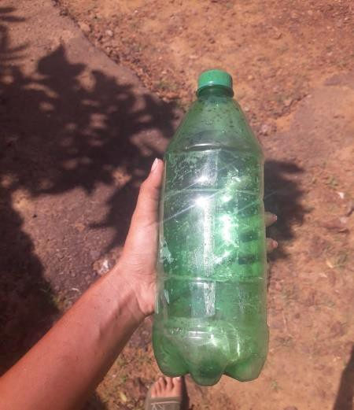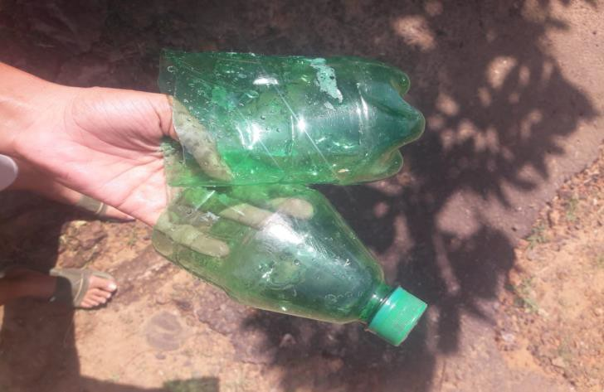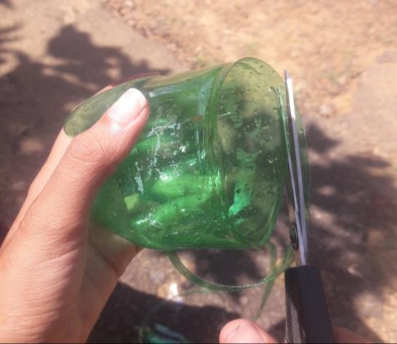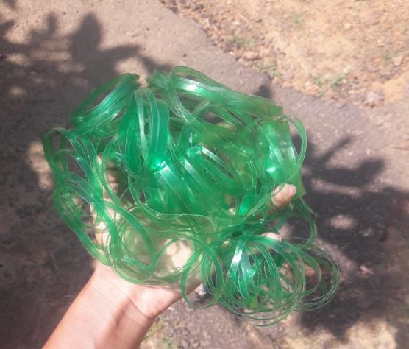

**Architectural Merits**

## Sustainability

The design adheres to principles of **circular economy**, repurposing materials that would otherwise contribute to waste streams.

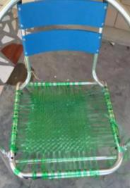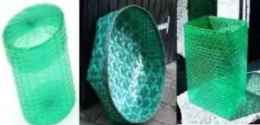Decorations and structural components are designed for **post-Christmas adaptability**, enabling their reuse in practical applications such as brooms, drying lines, or decorative installations.

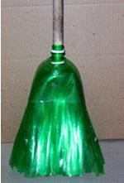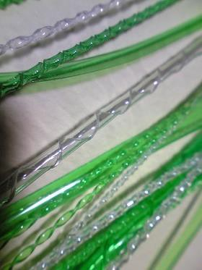

## Cost Efficiency

The project leverages **readily available, discarded materials**, ensuring minimal material costs while promoting the

creative use of local resources.

Its adaptability allows replication using common circular elements like pots, rims, or baskets, emphasizing accessibility.

## Ecological Responsibility

By eschewing the use of natural pine trees, the design actively mitigates deforestation and contributes to a reduction in

carbon emissions.

The temporary use of vehicle components ensures that they can seamlessly return to functional use after the festive season, emphasizing **reversible design**.

## Design Versatility and Replicability

This modular and **contextually responsive design** is adaptable to various material contexts, making it a **scalable solution** for diverse urban and rural settings. Its reliance on universally available geometries ensures its accessibility across cultural and geographical boundaries.

This sustainable Christmas tree serves as an exemplar of **architectural ingenuity** in the context of festive design. It celebrates the **intersection of form, function, and sustainability**, presenting a vision for how architecture can meaningfully engage with environmental challenges through creativity and innovation.

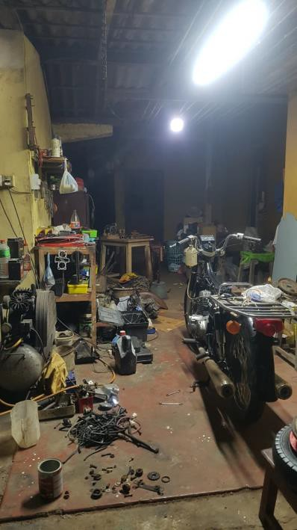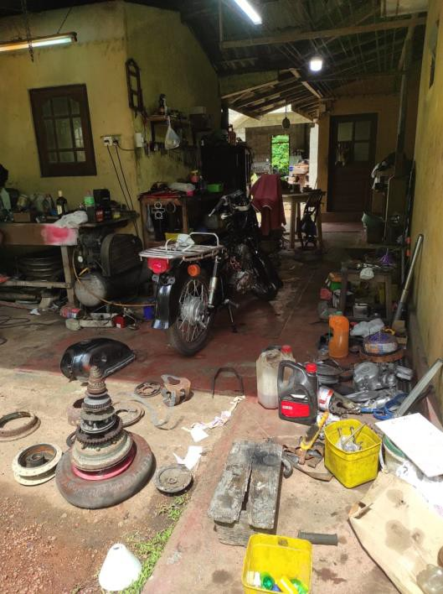

The place Where I found material

